**SOL FOREST SCHOOL**

~Family Handbook ~

**2019 – 2020**



“When children are exposed to nature, they reveal their strength.”

-Maria Montessori

**Sally Anderson, MA+**

Sol Forest School Founder, Director & Educator & “Guardian of Childhood”

[**www.solforestschool.com**](http://www.solforestschool.com)

**#505.259.2133**

**Sol Forest School Mission & Future Vision**

**Soulful-Outdoor-Learning**

At Sol Forest School, we believe in what esteemed Psychologist, Lecturer and writer Peter Gray refers to as “Mother Nature’s Pedagogy” as being the best learning approach for young children. We believe humans are wired to learn through nature and that they grow and develop best when schooled under the sun, climbing trees and playing with sticks. We are committed to re-wilding childhood and ultimately re-claiming the habitat of children, whether it be in an urban alley, suburban backyard or a nearby wilderness. We do this by offering Forest School programming in the East Mountains and the greater Albuquerque metro area, and through contract work with the City of Albuquerque Parks and Open Spaces division. In addition, we also provide Nature and Place-based Educational Consulting and training to other Educators, as well as training to existing Forest and Nature Programs on how to be more inclusive by welcoming children with diverse learning needs (SOL’s Director “Miss Sally” spent numerous years in the Special Education sector).

In addition, Sol Forest School offers additional ways for families and children to connect to the Natural World via community clean-ups, potlucks and family hikes, Woodland Birthday parties and special events, and connection to local events taking place in the greater Albuquerque area that aims to get children and families outdoors.

**What is Forest School?**



As a child, do you recall roaming freely outside in nature? Jumping in a leaf pile, making a mud pie, crunching an icicle, catching tadpoles or lightening bugs or.....climbing trees? It's possible that you, a parent of a young child, can recall a childhood filled with natural wonder, or at least remember fond memories of camping or going to a lake, river or ocean in the summertime. It's highly likely, however, that your child's grandparents definitely remember the days of wandering freely, sometimes from sun-up to sun-down, embarking on all kinds of outdoor adventures, regardless of where they grew up. Sadly, most children today, both here in the Albuquerque area and beyond, have lost their habitat as well as their right to play-in and connect-to nature.

Forest School is a rapidly growing early childhood movement that seeks to re-create what was once considered a “normal” childhood by connecting young children to the wonder, awe, adventure and learning that occurs in the outdoors when forming a relationship with the natural world. Forest School is an Early Childhood movement rooted in Europe, with pedagogical similarities to Montessori, Waldorf and Reggio Emilia approaches. Forest School programming comes in a variety of forms: Some Forest School children spend all of their day outside, rain or shine. These programs are often referred to as Waldkinders, or Forest Schools / Forest Kindergartens in the US. In other programs children from an existing preschool may visit the same natural setting at least six times throughout the year, to learn of its' secrets and witness the change of seasons. Forest School can take place literally in the forest, or in other natural spaces such as mountains, deserts, fields, and / or beaches. Sol Forest School is modeled after the Waldkinders in Europe and Canada. We run our program year-round and entirely outside, “rain or shine”, embracing the Scandinavian philosophy that “there is no such thing as bad weather, just bad clothing”.

**What do children gain from attending a Forest School?**

Child-led, open-ended nature play offers multiple opportunities for learning because the outdoor environment is constantly changing. The beauty of using natural objects (sticks, stones, leaves, pinecones, snow, etc.) in play is that children need to use their language

and cognitive skills to communicate the meaning and purpose of an object to each other. A stick, for example, becomes a telephone, a crutch, a magic wand, a car, or a fishing pole (etc.) in the development of a play scenario. Children spontaneously invent more creative plot lines in play where they are not surrounded by toys or materials with a predetermined use and meaning. Nature play in a Forest School setting also assists children to develop their Emotional Intelligence and grit, characteristics that educational researchers are finding to be increasingly more important traits for students to develop in order to succeed in school and more importantly, face life’s constant challenges. Self-awareness, self-confidence and self-esteem all typically increase in a Forest School setting because of the exciting challenges children are faced with such as hiking up rugged, steep terrain and climbing trees. Forest School also encourages a deep appreciation for nature and place, helping the child to feel connected and grounded right where they are living.

As it turns out, while you or your parents / grandparents were “just playing outside” skipping rocks and building forts, you / they were actually getting plenty of what author Richard Louv refers to as “Vitamin N”. “Vitamin **N**ature” in the form of sunshine, fresh air and movement reduces the risk of illness, obesity, diabetes, asthma, ADHD and depression while also developing school readiness skills. Children who participate in Forest School programming predictably develop initiative, persistence, invention, creativity, problem solving, critical thinking, empathy and social skills. In fact, research is now clearly showing that Forest Schooled children arrive to 1st grade much more ready and eager to learn than their non-Forest Schooled peers. Perhaps this is because, as Maria Montessori once said, “When children come into contact with nature, they reveal their strength”.

**What is child-directed or child-led learning?**

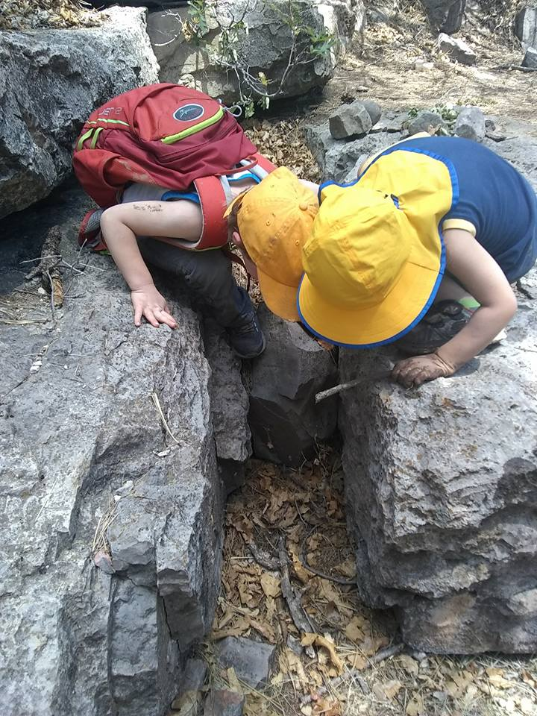

Forest School and place-based education pedagogy, much like the Waldorf, Montessori and Reggio Emilia approaches, places the child at center while believing that children are born inherently capable, curious, creative and competent. Child-interests are observed, honored, followed and built upon and because of this Forest Schooled children are often highly engaged in the learning process. Teachers provide “provocation” for learning as well as ample opportunities to explore early Literacy and Math skills. Teachers at Sol Forest School are familiar with both the NM Early Learning Guidelines (ELGs) as well as Piaget's Behavioral Schemas, ensuring that children are being exposed to what they should be prior to Kindergarten or 1st grade. When the teacher serves as a “Co-Collaborator of Learning” in this way, asking the right questions at the right time while still allowing for the child to experience the joy of wonder, beautiful learning takes place. And at Sol Forest School we truly believe wonder is the seed of wisdom!

**Who can attend Sol Forest School?**

We welcome all children from all backgrounds, with or without outdoor experience, who are 3 years old by August 1st (or January 1st for spring semester enrollment) and are toilet-trained for our weekly Waldkinder sessions. Children who are no older than seven years of age on August 1st may also attend. Our 1st Saturday Forest Fun sessions are open to children aged 3-10 years, extending this kind of learning and socializing to older children.

Sol Forest School children must demonstrate age-appropriate independence in walking on their own, carrying their own backpack, taking their own clothes on / off, managing their personal belongings, listening to others (especially adults, as it relates to safety) as well as demonstrating a desire to participate in and stay with the group.

**Location : Forest School Sites**

Sol Forest School utilizes sites in the East Mountains including Chamisoso Canyon, Ojito de San Antonio Open Space, Pine Flats, and a Sandia Mountain site close to the Faulty Trailhead (just two miles up the Crest Road). We are also exploring potential sites in the Bosque both in Albuquerque and Rio Rancho (at Trailhead Park). Which site is used may be determined by increased bear activity (fall) in the East Mountains and / or by potential closures for wild fire risk (any time of year, but more likely spring-summer) and / or winter snow closures. Our intention is to use the same site, however, over the course of the semester or school year, so that our children develop an intimate relationship with that place.

**SOL Forest School Staff**

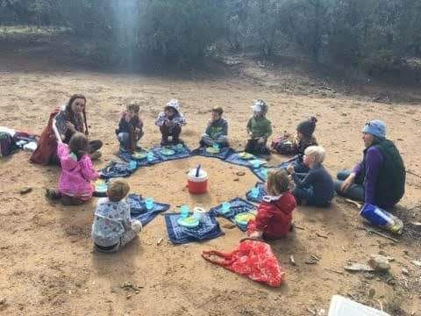

All our paid staff are experienced teachers with MA degrees and training in the Forest School philosophy as well as expertise in a variety of areas. They are also Wilderness First Aid (WFA) trained. Two teachers co-facilitate each session of no more than 14 students creating a 1-7 adult-child ratio. We currently offer an opportunity for 1-2 parents to work with us, as well, providing a third adult during sessions, for reduced tuition. Having a third adult allows us to break into smaller explorer groups or to split the children up into an older and younger group for specialized activities and instruction and brings our ratio down to 4 or 5 children per adult.

Sally Anderson, Sol Forest School, LLC. Founder, Director and Lead Educator, brings 30 years of experience working with young children to SOL. She spent most of her career working with young children who are deaf or hard of hearing, so her sessions often weave in the learning of basic American Sign Language (ASL) in addition to typical Forest School learning activities. Sally also worked as an Outdoor Educator and Summer Camp Leader for a number of years earlier in her career. She holds Early Childhood, Special Education and Educational Leadership certifications as well as a Forest School Practitioner certification from Forest Schools Canada. In fact, she was the first educator from the United States to earn her certification from Forest Schools Canada and is the only person in the state of New Mexico who has completed a comprehensive Forest School training program! In addition, Sally is a trained Tinkergarten Leader and she teaches classes and acts as a Mentor to students attending alternative educational paths at Prescott College in Arizona.

**Tuition**

We are a tuition-based program, meaning parents either pay in-full for Forest School per semester or year (for a discount) or pay per session, regardless of whether or not their child attends. Since we are a small, developing LLC, the “promise” of tuition allows us to cover all our basic program costs, hefty insurance coverage, staff salaries and also project and plan into the near future for program expansion. Only in rare circumstances will tuition already paid be reimbursed (at 50% of the number of sessions remaining) or allowed to be “skipped”. Parents are expected to sign a tuition agreement expressing their desired payment plan and there is a charge for late payments. Please understand that we earn very little for all the heart and soul we put into our work at Sol and that every penny shared via tuition goes to very good use! (More information regarding our current tuition rates can be found in a separate tuition document).

**Will SOL children really go outside in all weather?**

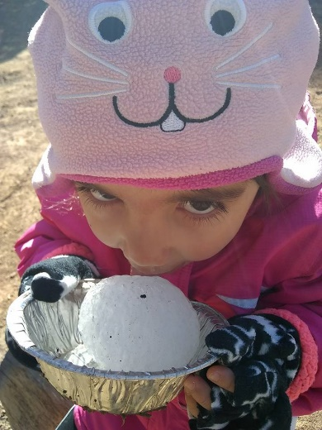

Yes! The only time we will not hold our session is if there is an APS2-hour delay or school closure, or if the wind, heat or rain is so significant it would be harmful (or very, very uncomfortable) to be outside for our session. There will be no tuition reimbursements for 2- hour delays, snow days or excessive weather conditions resulting in the first few cancellations in line with the APS East Mountain schools. We will, however, attempt to offer a make-up session if several sessions are missed. Thankfully the mild, sunny, comfortable year-round climate we have all grown to enjoy here in NM almost ensures that most (if not all) sessions will run each Forest School semester. Having said that, weather in the mountains can vary drastically over the course of a few hours so making sure your child is dressed properly and prepared with back-up clothing is of the utmost importance!

**Dressing Your Sol Forest Explorer for Mountain Weather**

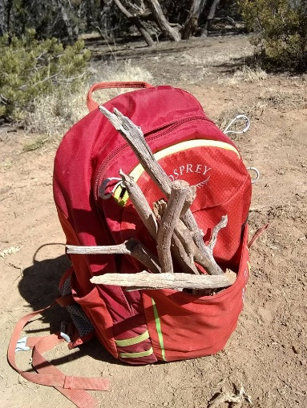

In Scandinavian Forest Schools there is a popular saying, “There is no such thing as bad weather, only bad clothing”. The first step towards ensuring your child stays warm, dry and / or cool is related to dress. It is YOUR JOB to dress your child appropriately for Forest School. The key to dressing in our NM climate- the high mountain desert- is to wear layers because we experience significant daily temperature fluctuations all year round. Also keep in mind that your child can always remove clothing to regulate their body temperature, but they cannot add clothing if they do not have clothing to add. We will discuss clothing in detail during the registration process and can assist you with clothing suggestions at any time. If you are unable to afford appropriate outdoor clothing let us know as we do have a small lending library that you can draw from and/or we can call upon other families within our Sol community. Savers, Goodwill and Re-Gear are all good places in town to find high-quality outdoor children's clothing.

Please understand that if your child is not dressed appropriately and suffers as a result we will give you one warning. The second time it occurs we will call you to come and pick up your child. Please also understand that your child / children WILL get dirty, or even muddy, and that their clothes will get torn, scuffed, ripped and /or sticky with pine-pitch (on occasion). Basically, if they aren’t dirty, they didn’t play so if keeping clothes and high-end outerwear neat and clean is a high priority for you, we recommend you have separate Forest School outfits and you buy outdoor clothing used.

It is a common parenting trend these days to allow ever-younger children to "make their own decisions" which Sol supports, but in the past this has sometimes amounted to parents arriving to a session explaining that their child "didn't bring their jacket today because they didn't want to". Or, perhaps the child didn’t want to wear close-toed shoes, or any shoes at all. Please know that handling dressing decisions in that way is not "optional" for children attending a Forest School and if they are not properly outfitted, they cannot participate. We are more than happy to support you in explaining this to your child and assisting you in setting up expectations so that they will remain comfortable while outdoors.

Each child is expected to have the following on them and/or in their personal backpack at all times:

• Backpack & water bottle

• Closed-toe shoes & socks (all year round)

• Sun Hat (all year round)

• Bandanna (summer- we will roll them up, wet them & wear them around our collars to keep cool)

• Extra pair of underwear (all year round)

• Extra pair of socks (all year round)

• Extra layer (all year round; a long-sleeved shirt for shade / warmth in warm months & a fleece or sweater in cold months)

• Warm hat, gloves / mittens & scarf in the winter months

(November- March)

• A winter jacket, fleece, hoody or warm sweater (depending on the season)

• Long Johns under jeans / pants in cool / cold weather; add snow pants during winter / snowy weather (NO cotton)

• Snow boots in cold winter weather (i.e. Bogs or Sorrels)

• Rubber boots in the muddy spring (or Bogs)

• Rain coat during monsoon season

Please be sure all clothing items are labeled with your child's name and any extra items (socks, underwear, etc.) inside your child's backpack is in a large Ziploc bag.

**Sol Forest School Sick Policy**

Caring for a sick child in an outdoor environment is much more challenging than in a traditional preschool setting. If your child is not feeling well please be sure to take their temperature before bringing them to Forest School. If they have an elevated temperature of 99 but seem to be feeling okay they may attend, but 100 and above is considered a fever and they should remain at home until they are fever-free for 24 hours. Nausea, vomiting and diarrhea cannot be well-managed in the outdoor classroom, so if there is tummy discomfort of any kind please keep your child at home. In addition, children with mysterious rashes and / or an active cough should have their temperatures checked and if they are unwell, they should stay home. We cannot administer over-the-counter cold or allergy medications so if your child depends on these please time their dosing to align with the session schedule. We do carry a thermometer with us out in the field so if your child is complaining of feeling unwell, we will check his / her temperature and call you if it seems best they be picked up early.

Interestingly, research is now showing that children who attend Forest School programs suffer significantly less colds, flu and other illnesses! One of the reasons for this is the theory that germs entrapped in the confines of a classroom typically spread (and sometimes linger) as opposed to germs that are exposed to “good ole fashioned fresh air”. In the latter instance germs have much less power to make people sick. One more plus for learning in the outdoors!

**Snack, Lunch & Birthday /Special Events at Sol**

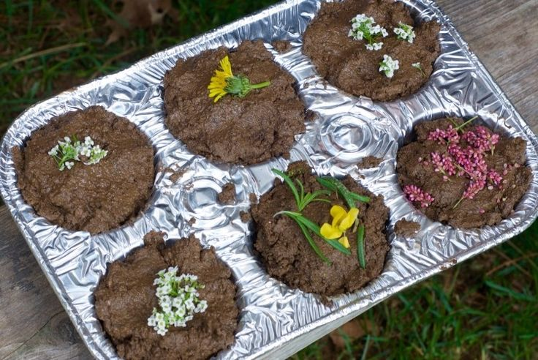

Sol Forest School believes that the food we eat fuels our bodies and the cleanest fuel we can consume while we are expending energy in the outdoors is in the form of whole and simple foods. We will provide a healthy morning snack of fruit or veggies along with cheese and crackers, popcorn, graham crackers, oatmeal cookies, fresh bread and butter, celery and peanut butter, baked potatoes (in the winter), yogurt, etc. These no or low-sugar snacks will be consumed with water in the warm / hot months and hot drinks in the cold months. You are welcome to pack additional snacks if your child is a big eater as they will always have the option to snack if they are hungry. We do not share snacks brought from home, however, and we will always encourage the consumption of what we have brought along, first.

Lunch is packed by you for your child and needs to be something that s/he can manage somewhat independently. Healthy options include sandwiches, cheese and crackers, hummus and veggies, cold noodles with veggies, cereal and milk, bean dips, tortilla wraps, soup in a thermos, oatmeal in a thermos, etc. We prefer that cut fruit and yogurt be placed in a re-usable container vs. purchasing individual throw-away containers. Please stay clear of any sugary drinks (juice included), sugary “treats”, processed chips, etc. Please also be sure that you are able to keep your child's lunch cool enough during the warmer months. We do not allow children to share or swap food and do not enforce any “rules” around eating (“You must have this before you have that”, etc.). We assemble in a circle prior to snack and lunch and enjoy a brief, non-secular blessing on our food that typically involves thanking the Earth for providing it, before we eat. This is a ritual that builds patience, gratitude and community.

Birthdays are a special event that should be celebrated! Your child will have the opportunity to make a “nature crown” for their birthday or something else of their choosing. We will sing to them and honor them during morning snack or lunch. We welcome you bringing in or sending a special birthday snack of home-made muffins, a quick bread (banana, pumpkin, etc.), croissants / fresh bagels or cookies but we cannot manage cake or cupcakes with messy icing in the outdoor environment.

We may require all our children to be nut-free during our sessions or shared snacks to be gluten-free, if the diets of our children dictate. We will let you know if there are special restrictions in place.

**First Aid & Emergency Procedures**



All of our Sol Forest School staff are First Aid and CPR trained. Miss Sally (Sol Director) and Miss BrieAnne (Lead Teacher) also hold Wilderness First Aid (WFA) certification from the National Outdoor Leadership School (NOLS).

All of our forest school sites are less than a 10 minute (adult pace) walk out and within very close proximity to the Tijeras Police and Fire Stations as well as the Sandia Ranger District. There is also an Urgent Care center (Pineridge UC) nearby in Cedar Crest.

Our cell phones have been tested and found to be in effective operation at all of our forest school sites. In the event of a true emergency, the 911 response time is expected to be immediate.

Our children do climb, spin, throw, run and do other things that can result in injury. We are also playing on ground that is not manicured, so it is uneven and there are rocks, cacti and even embedded broken glass that can be stepped on. We do our best to eliminate hazards and minimize risks, but injuries can and do happen (in 6 years of doing this work, however, the most serious injuries thus far have been deep scratches from tree branches and encounters with cacti needles). Potential injuries and matching emergency responses are categorized as follows:

**Level I injury-** In the event of a mild injury (cuts, scrapes, bumps, falls, cacti "splinters", etc.) not resulting in urgent attention we will treat the child and injury and tell you verbally and / or send a note home in your child's backpack with an explanation of what happened.

**Level II injury-** In the event of a moderate injury where the child is not in imminent danger but s/he is clearly hurting or does not feel well, we will contact you to explain what has happened and reach a consensual agreement regarding next steps (early pick up, etc.).

**Level III, an emergency-** If the emergency is truly life-threatening, we will call 911 first and the parents second. We will then separate the children who are not hurt from the child who is, moving to a different location within the site to calm and contain the group. Miss Sally (Sol Director) or Miss BrieAnne (Lead Teacher) will accompany the injured child to meet the ambulance crew (with a second adult, if a carry is necessary) while our other adult/s stay with the group. If the injury is serious, but perhaps not life-threatening, Miss Sally (Sol Director) or Miss BrieAnne (Lead Teacher) will contact the family and drive the child to Urgent Care in Cedar Crest.

The most important thing to remember is that we will make the best call we can in any given situation and by enrolling your child at SOL Forest School, you agree to place your trust in our ability to make sound decisions.

**Site Emergency / Unexpected severe weather change.**

If some kind of unforeseen event takes places requiring us to evacuate our site prior to 1pm we will vacate to the Tijeras Library. Parents will be contacted once we arrive safely to the library (or, if not in the East Mountains, to the nearest library or McDonald’s). ALL parents / guardians will be expected to sign a release at registration allowing any SOL staff member, volunteer, or SOL parent to drive their child / children in their personal vehicles in the event of a serious injury requiring immediate medical care, or a need to leave the site to evacuate to the Tijeras Library. There may not be enough car seats to accommodate all our children, but we will be sure to buckle them in for the short drive to the Tijeras Library.

Parents are encouraged to ask questions, read the materials available on the SOL website, and do their own research regarding the potential of injury in a forest school program. While there is always the potential of harm, we work tirelessly to manage the forest school setting to mitigate risk and injury. Our efforts include, but are not limited to, cording the parameter of our site so the children know exactly where they can / cannot be, daily site management, the application of regular risk assessments (of several varieties) that aim to reduce / eliminate risk and injury, maintaining local connections and contacts, and working continually with your child/ children to teach them about risk and how to manage it in the forest school setting. The best assurance against a potentially serious injury to a child in the outdoors comes through teaching them to assess their own limits, abilities, areas of weakness, readiness and confidence and this is done by coaching them through new, sometimes risky and often exhilarating, experiences.

**Rules at Sol Forest School**

We really only have one rule at SOL Forest School: **The Rule of Care**. We promise to demonstrate care for ourselves, care for our things, care for our fellow SOLTreeschoolers and care for our outdoor classroom / environment (including materials, equipment and our beautiful site) at all times. When our teachers deal with "bad behavior" at SOL it's usually easy to connect it back to **The Rule of Care**. We will simply ask, “Mary, are you showing care for your things by emptying all the contents of your backpack and leaving them strewn across the ground? Billy, are you showing care for Tommy by pointing that big stick in his face?”, etc. We recommend trying **The Rule of Care** at home as it is a gentle form of discipline and highly effective. Children love consistency, too, so they will also enjoy knowing that the rules at home and the rules at Forest School are the same.

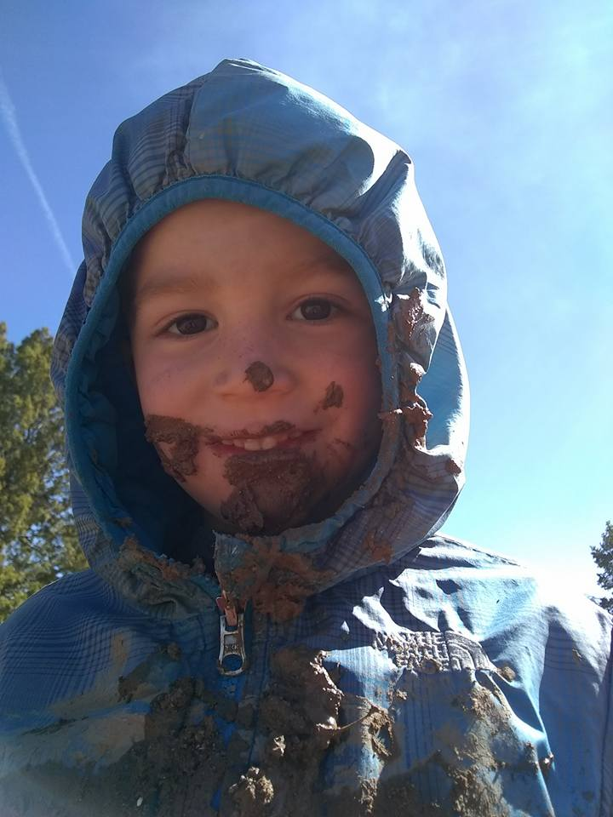

**Sol Forest School Behavior Policy**

Most children, given good role models and supportive guidance and opportunities, learn to care for themselves and others. Most people, children included, have a natural desire to keep themselves safe and out of harm's way, as well as a desire to not harm others. For these reasons, the majority of our SOL Treeschoolers quickly understand and practice the Rule of Care with themselves and others. Occasionally there is a child who may exhibit behavior that is different than the norm, however, who may need extra support to do the right thing. Due to the increased risks and challenges that an outdoor classroom poses, there is an expectation that children will be able to follow the set safety rules and procedures and as a result they will keep themselves and others safe. If a child fails to do this and becomes a liability to themselves and / or towards others the following steps will take place:

1.) First occurrence- Verbal warning

2.) Second occurrence- Verbal warning and communication with parent/s. Possible separation from the group if the behavior is severe enough to warrant doing so (attempting to push another child off of a boulder, intentionally hitting another child with a stick, refusing to listen to safety directions, running away from an adult, etc.).

3.) Third occurrence- Child will be separated from the group for a period of time to “calm down”. A meeting will also be held with the parent/s. A behavior plan will be written up and the child will have two more sessions to demonstrate a willingness and / or ability to follow the safety rules. If s/he is able to do this, then things will start afresh. If s/he is not able to do this, then s/he will be asked to leave Sol Forest School. Parents will be reimbursed up to 50% for any tuition they have already paid in full for remaining Forest School sessions that the child will now be unable to attend.

A note about learning to be social with others: We are all social beings and learning to navigate our needs and desires, as well as sharing those needs and desires, is often challenging when we are young and still developing. Children, like adults, come in all kinds of temperaments and sadly our culture quickly labels children who “misbehave” or are less regulated than others their age. This most often happens to boys and there are countless reasons why active or “challenging” boys act in certain ways, and usually it’s not to be intentionally mean or cruel.

SOL staff are committed to being fair, consistent, and encouraging to all of our children all of the time, and we will always air on the side of believing that children are doing the best they can with the current skills they have (vs. thinking that they are intentionally hurting others). We will hold this belief while also keeping everyone safe, using our Rule of Care and behavior policy as tools. If there is a social scuffle, we gather the children involved together and take turns speaking, giving everyone a fair turn (if a child has been physically hurt or their feelings are very obviously hurt, we’ll often place attention on that child first, bringing awareness to how they are looking and feeling). This kind of fair, neutral, calm approach helps children to feel heard while also developing the skills of empathy and perspective-taking. These skills are very important to develop in a time when people are often quick to judge or write-off others that do not believe the same way.

After decades of working in education it is disheartening to see that not only do a large number of American parents “bubble-wrap” and protect their children from physical harm, but there is a new growing trend towards also protecting our children from “emotional harm”. While cruelty or bullying would never be tolerated, it IS normal for typically developing children, even good-tempered children, to try on different characteristics and ways of being. The old, “You aren’t my friend anymore so you can’t come to my birthday party!” phrase comes to mind here…..this is normal behavior for most children to “try on” at some point in time. We hope you as parents can understand this and also know that we are always attending, listening, modeling and practicing our Rule of Care as best we can at Forest School.

**Risk and Adventure at Forest School**

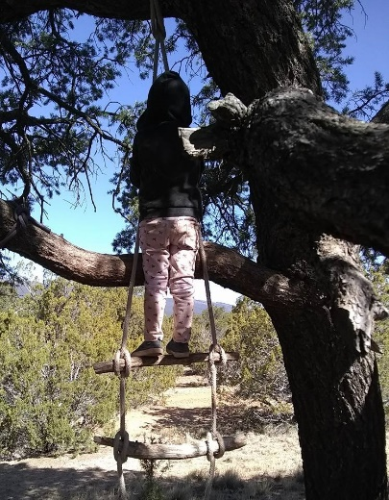 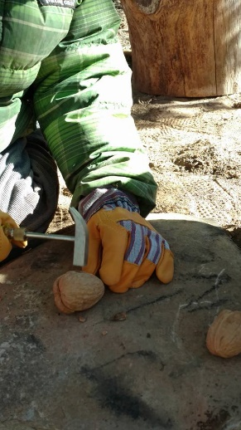

Your child will be challenging themselves in new and exciting ways at SOL Forest School! This feature of Forest School learning is significantly important because it directly relates to the development of Emotional Intelligence (i.e. the ability to self-regulate). SOL sessions are carefully managed to ensure the safety of all the children. This is accomplished in a number of ways, such as the following:

* We return to the same site over and over again so the children become familiar with one place (and the adults are responsible for assessing the site for safety issues prior to each session)
* Children are taught their outdoor classroom boundaries (made visual with cording delineating the site boundary) so that they learn where they have the freedom to explore independently
* Children might wear bright safety vests so that staff members can visually see them at all times, if a particular site offers less visible access to the children for the staff
* “Gathering Drills” and “Bear Drills” will be practiced frequently so the children grow accustomed to quickly returning to the group
* Constant dialogue about what is safe / not safe will be on-going (for instance, “Is it okay to eat plants while in the forest”; “What do you do if you see a snake?”, etc.)
* Children are coached through “risky” activities such as tree-climbing, boulder scrambling, tool use, etc. and caring adults are always on hand supervising and talking with the children, particularly when they are attempting to do something for the first time
* Children learn to take responsibility for their actions and to take care of their site, developing a connection to this place they learn to steward.

In this managed yet adventurous environment children quickly learn to assess potential challenges and risks, building their self-knowledge and confidence as they go. And, as stated above, developing self-knowledge of one’s skills enables children to learn what they are ready for, or not ready for, when encountering new experiences that do have inherent risks attached.

Prior to SOL Forest School enrollment parents / guardians are required to read an article that explains the risks and benefits of adventurous play, and/ or to have a discussion about this with SOL Director, Sally Anderson, via phone. Parents are also required to sign a consent form for their child / children that clearly states that there are risks involved in attending a Forest School program that could result in injury to a child, ranging from mild to serious, to fatal, and sign consent to participate.

**What does a typical Sol Forest School session look like?**

This is a glimpse at our daily routine. Time spent in each area is dependent upon current child interests:

* Session group assembles & walks into the site together, perhaps stopping along the way for dialogue &/or mini adventures!
* Welcome Circle (while one adult conducts a site assessment, if it did not occur earlier in the morning) followed by a brief group or individual Sit Spot, if the children are developmentally ready.
* Free Forest Play
* Hand-washing, Snack, Story-time
* Choice Time (organized games, Arts & Crafts, tool use in the "Bloodline", etc.) &/or more Free Forest Play
* Talking Stick Circle & Forest Farewell Ritual
* Walk back to meet & eat with parents
* Handwashing & Lunch (children bring their own lunches)

**What kinds of activities might my child participate in during a typical SOL Forest School session?**

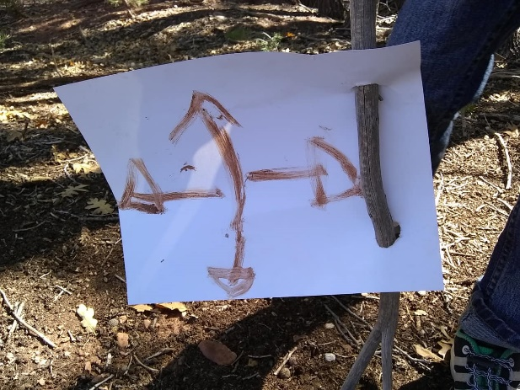

* Story telling & socio-dramatic play
* Dirt Kitchen & Mud-mixing play
* Nature crafts, painting & journaling
* Knot tying & Tarp building
* Stick “whittling” (with a carrot grater vs. a pocketknife, to start), sawing & hammering (all with adult supervision and guidance, typically inside the “Bloodline”)
* Scavenger hunts, bug hunts, fort-building
* Map reading; nature guide reading; nature-themed story books
* Sit Spots
* Jumping, running, throwing, splashing, climbing, swinging, spinning, balancing, building, transporting, carrying, stirring, bending, transforming, berry or herb picking (under adult care), drinking “wild” tea, eating, laughing and having FUN!
* And…SO MUCH MORE!

**SOL Forest School Parent-Communication and Child-Progress-Checks**

Sol teachers will regularly post on our Facebook and / or Instagram pages to share what’s happening during our sessions with our parents. This is a great spot to watch for fun stories of learning and adventure in the forest.

This year we will also trial a new platform called Story Park that allows for a richer sharing of group and individual learning stories, while also weaving in the NM Early Learning Guidelines. Our hope is to measure, anecdotally and through documentation, your child’s progress through the year. You will be invited to join this platform and in so doing, you will be able to share anything about your child to anyone important to him/her, such as other teachers or grandparents, by inviting those folks to join Story Park. There is a small, monthly, per-child cost to add a student to Story Park and as we trial the platform, SOL will incur this cost. If the trial is successful, however, we will likely increase our registration fees or have a separate Story Park fee of $5.00 or less a month per child, to keep it going.

Please also check the sign-in / out book at drop off / pick up and your child's backpack after each session to see if there is information related to upcoming events, schedule changes, informational readings, or a personal note regarding your child that requires your attention.

SOL teachers can also provide a verbal report of progress at parent's request, at any time. And we will certainly approach you with an “big” news (success stories as well as areas needing improvement).

**Environmental Attitudes and Practices at SOL**

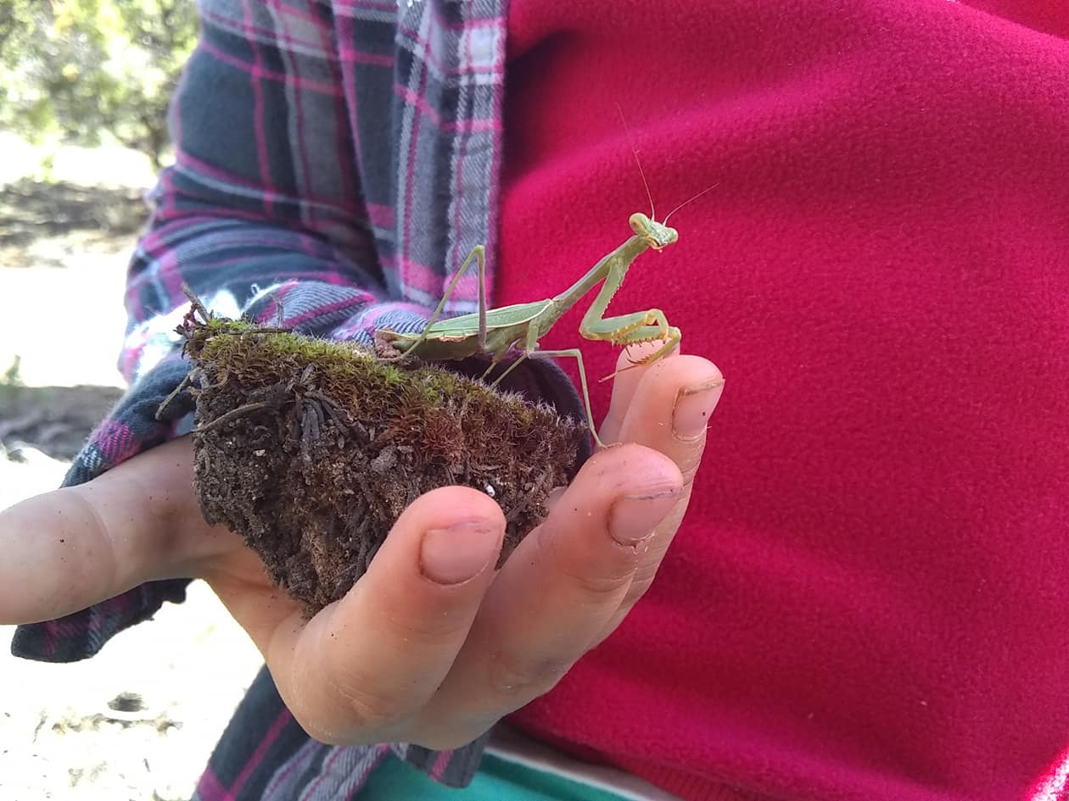

SOL Forest School was founded in large part because the Director saw a real and urgent need to reconnect children to the natural world. We have attempted to address here how this connection benefits the child, but it also benefits the environment! 99% of adult Environmentalists speak to having spent significant time as a child in the embrace of the Natural World. In our modern, consumerist and technologically driven culture less and less emphasis is being placed on conservation and caring for natural places. If we do not begin to raise a new generation of children who love nature, we will not have future adults who wish to work on her behalf!

A deep respect for nature is woven throughout our program. We begin each year with a special day that includes invited guests from one of our neighboring Pueblos who opens the Forest School year by providing a site blessing, as well as Native American stories, songs and activities that anchor us in place and history, while also encouraging us to have (or deepen) our reverence and respect for Mother Earth. When we gather as a large group we will practice Leave No Trace (LNT) principles and ask you to bring your own plates, cups, etc. to minimize waste. We also try, when possible, to purchase snacks in bulk, and to recycle or re-use any packaging or containers.

With the children, however, we adopt a philosophy that may be new to you: "Wild Tending" vs. "Leave No Trace" (LNT). While we would never encourage or allow a child to pick every wild flower in the field, we do allow it because it is our belief that LNT principles can separate us from nature, while “Wild Tending” suggests that there is a partnership in place between humans and the Natural World. Children learn by being in their bodies and using their senses, which might involve picking a fist-full of wild flowers, smelling them, crushing the petals on a rock to see if their colors bleed, throwing them up in the air, cutting the stems with a butter knife, etc. Young children are wired to want to explore their environment in this way, making them part of the environment, exploring their world, rather than separate from it. Allowing exploration to unfold in this way helps children to "know" the flower more deeply than just looking at and appreciating it would. This is not to say that we allow complete mayhem and destruction to take place! In fact, destruction rarely, if ever, takes place because we are companioning with the child / children as they play, asking questions and providing gentle guidance (including reminders of our Rule of Care), so it is often possible to encourage "exploration in moderation" through the Wild Tending approach.

In contrast, LNT would have the child "look but don't touch" and in our view, this perpetuates the myth of separateness between humans and the Natural World. We are nature and we want children to know this and experience this by interacting with the Natural World in a developmentally appropriate way. Enforcing LNT practices with young children creates a situation where natural objects are viewed as sacred museum pieces that are not to be manipulated (more separateness).

We periodically assess our use of our Forest School sites to determine if our impact is harming the place beyond repair. In addition, we usually host volunteer site clean-up days and hope to gift our forest new trees in the future, if given the blessing to do so by the National Forest Service.

**Final Note**

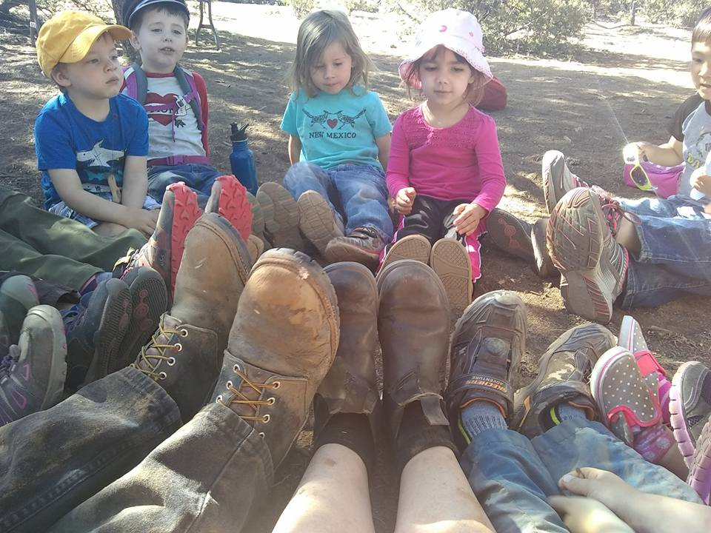

We do expect you, as a SOL Forest School parent, to read and review this Parent Handbook, as well as our website, before your child begins at SOL (and we will ask for you to sign-off on receiving and reading these materials each year). Please feel free to contact us with your questions, concerns, suggestions or commendations at any time.

**THANK YOU** for entrusting us with your child/children. We look forward to your child engaging in regular soulful outdoor learning at SOL Forest School!