friday, october 4th, 9-noon  Shinrin Yoku guided walk  Shinrin Yoku "Forest Bathing" has been practiced in Japan for over a decade & has been clinically proven to have a positive effect on our overall health. Come increase your NK (Natural Killer) cells while also slowing down & enjoying the beauty of the Bosque on this Forest Therapy walk guided by Sally Anderson.  www.shinrin-yoku.org/shinrin-yoku  Sally is a veteran educator who founded Soulful Outdoor Learning, or SOL, in 2017. She currently works full time as the Director & Lead Educator of Sol Forest School, a program for “Treeschoolers” ages 3-7 years old. She also works as an Educational Consultant for Albuquerque’s Parks & Recreation, as an Instructor at Prescott College & offers regular Shinrin Yoku forest therapy walks to the public. She lives in Tijeras but enjoys frequent wanderings amongst the tall Cottonwood Trees along the Rio Grande. | Details:  9-noon  Meet at the Pueblo Montano picnic tables at 8:50 am.  Wear walking shoes & bring a water bottle & sun hat / lotion.  -Limited to 20 participants  -RSVP via text to #259.2133 by Wed 10/2.  ────  This is a private, catered walk for the staff of the Albuquerque Parks & Recreation department. Come with an open mind ready to experience the Natural World in a whole new & reinvigorating way!  ────  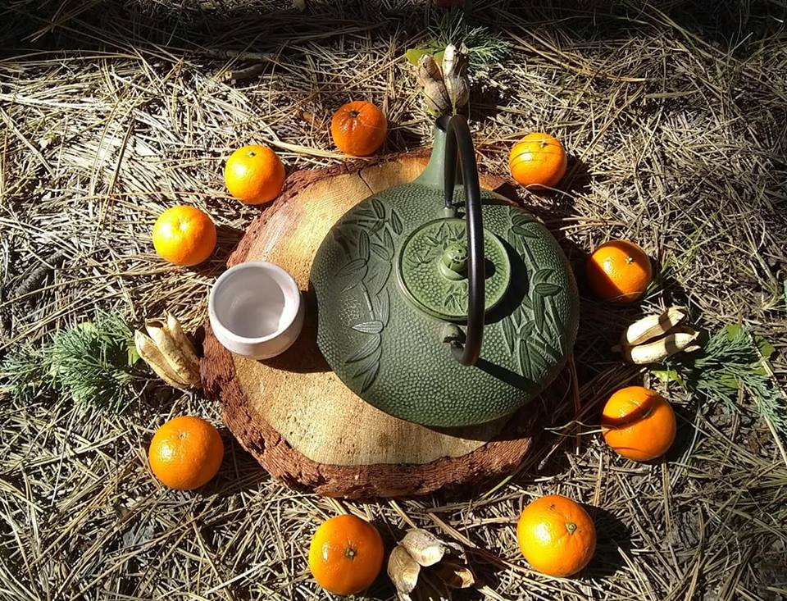  Sally Anderson  #505.259.2133  www.solforestschool.com  https://www.facebook.com/soulfuloutdoorlearning/  ────  